# INTRODUCTION

Eshop Spot is an electronic e-commerce web application, which retails various electronic products. This project allows viewing various products available enables registered users to purchase desired products instantly using PayPal payment processor (instant pay) and also can place order by using cash on delivery (Pay later) option. This project provides and easy access to administrators and managers to view orders placed using pay later and instant pay options.

In order to develop this e-commerce website, a number of technologies were studied and used. The technologies thus used are React and Redux, Node JS, Express JS and MongoDB.

The objective of the project is to develop a basic website where a consumer is provided with a shopping cart application and also to know about the technologies used to develop such an application.

# WORK DONE

## DESCRIPTION:

* + Any member can register and view products.
  + Only registered members can buy products regardless of the quantity.
  + There are three roles available: Visitor, User and Admin.
    - Visitor can only view the products.
    - User can view and buy products.
    - An admin has some extra privileges including that of User and visitor:
      * Admin can add products, edit product information and add/remove products.

## WEB PAGES DETAILS:

* + Home Page 4
  + Register Page 7
  + Sign-In Page 9
  + Products Page 11
  + Cart Page 12
  + Shipping Page 13
  + Payment Page 14
  + Order Page………………………………………………………...15
  + Admin View……………………………………………………….17

## PROJECT DETAILS:

# Eshop Spot ARCHITECTURE



**REACT JS**

**EXPRESS JS**

MONGODBB

HTML, CSS, JAVASCRIPT

BOOTSTRAP

**MONGOOSE**

NODE JS WEB SERVER

**Frontend Development Back-end Development Database Development**

**Eshop Spot APPLICATION**

Anyone can view Eshop Spot portal and scroll through available products, but only registered users can login and order products. If a visitor wants to become a user he/she has to first register in order to avail the benefits of a user. Visitors can register by navigating to the registration page and then fill in the required details. Only admin has the access to delete the user. Only admin can change the role of user from user to admin. If a person registers by default he/ she will be a user only.

# USER VIEW

## HOME PAGE:

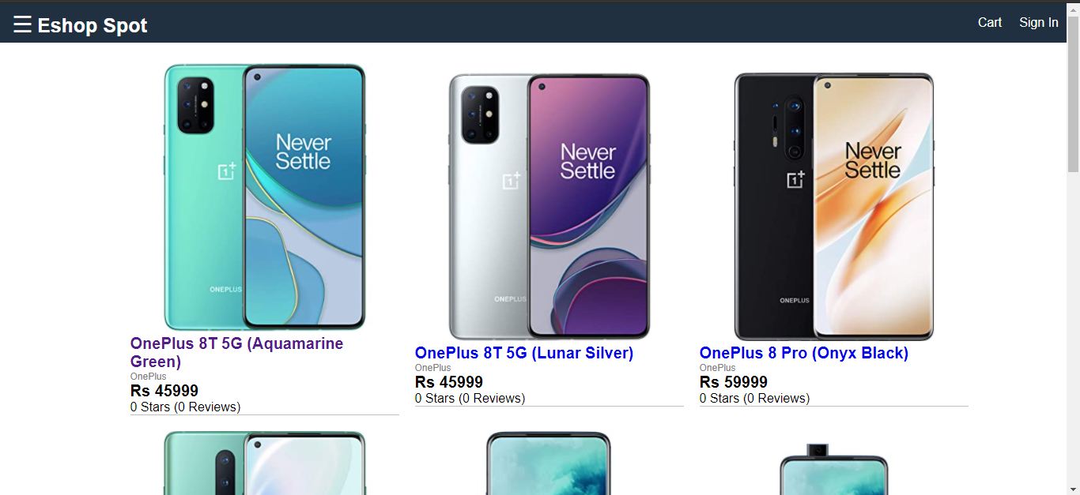Home Page is the first Page that is visible once we open the project. It shows all the products that are available on our website (Snapshot 1).

Snapshot 1

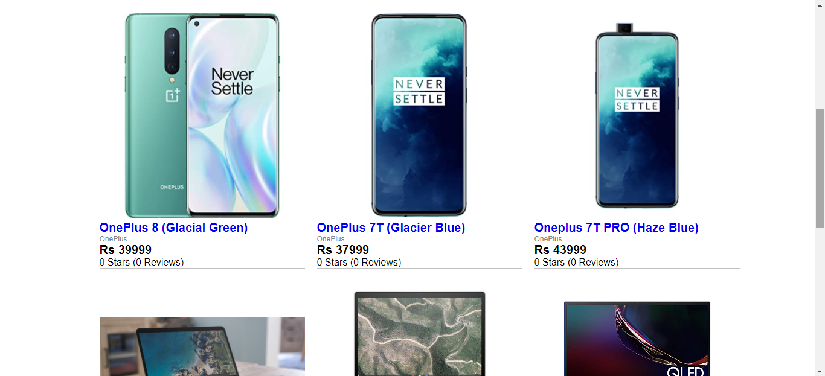

Snapshot 2

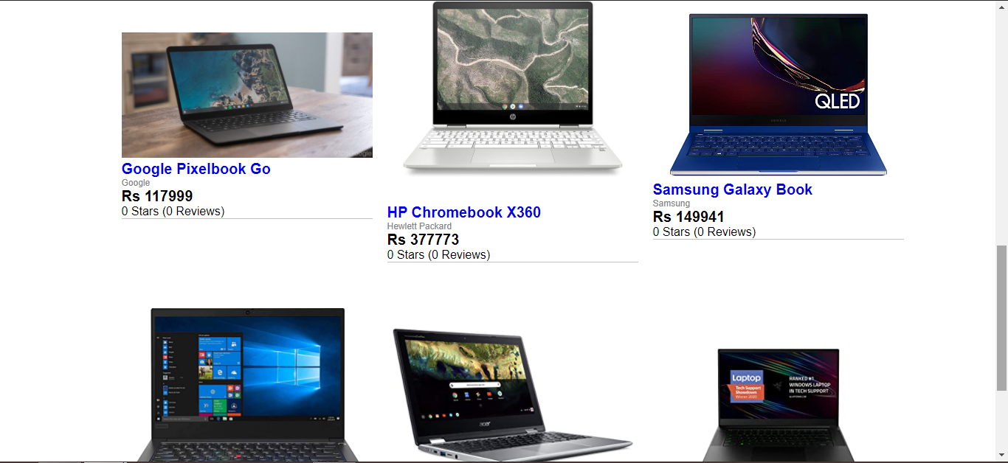

Snapshot 3

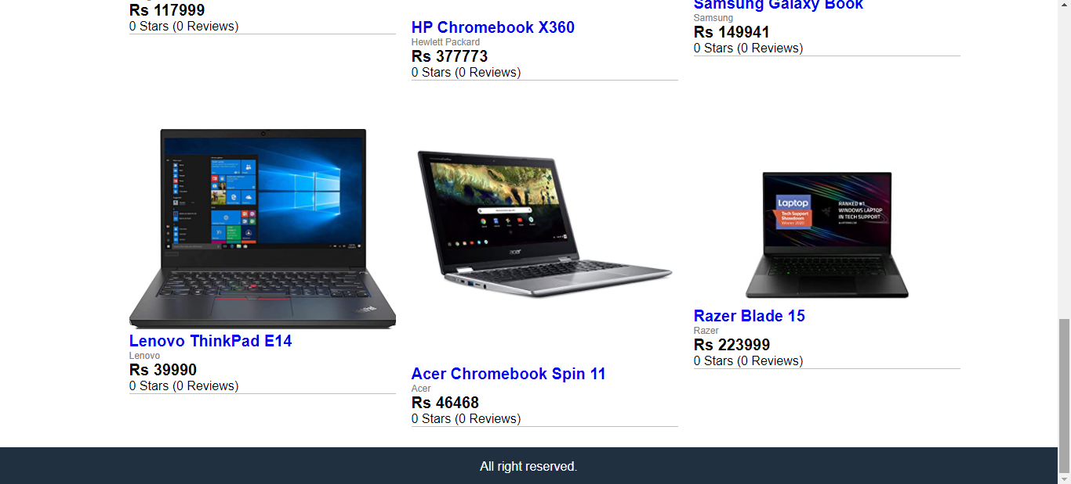

Snapshot 4

Visitor can scroll through all the products and reach at the end of the page (Snapshot 4). The navigation bar on the top of the page has an icon on the right side of the sidebar, the sidebar if opened shows the category of products (Snapshot 5), on clicking on the category only the products of those category will be shown.

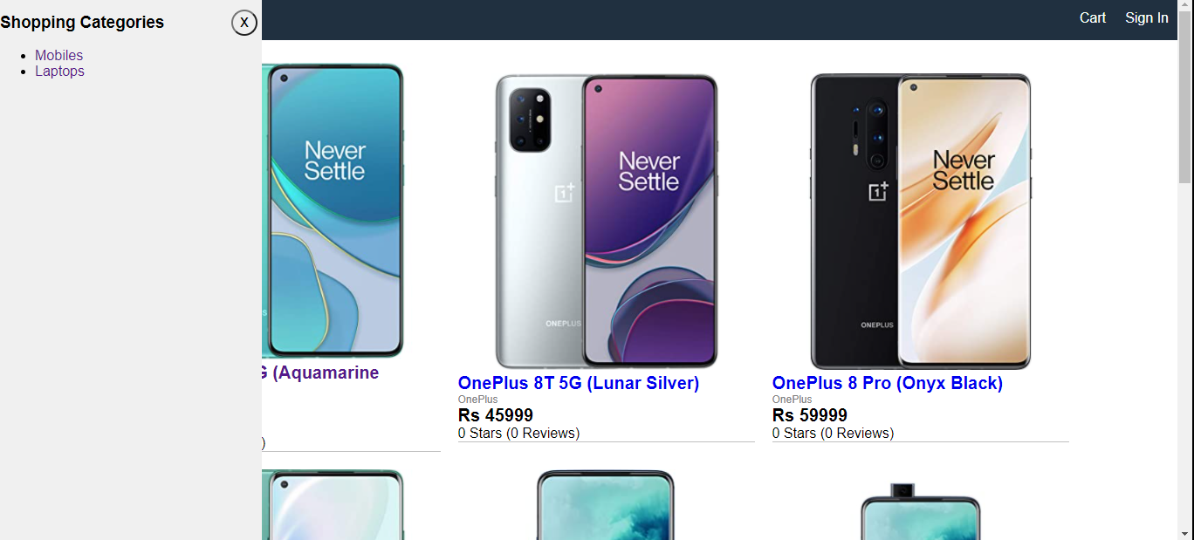

Snapshot 5

## REGISTER PAGE:

On the right side of the navigation bar there are two buttons, one is for cart and one is for sign-in. In order to add items to the shopping cart, a visitor needs to Sign-in first if he/she already has an account, if not then he/she has to register first.

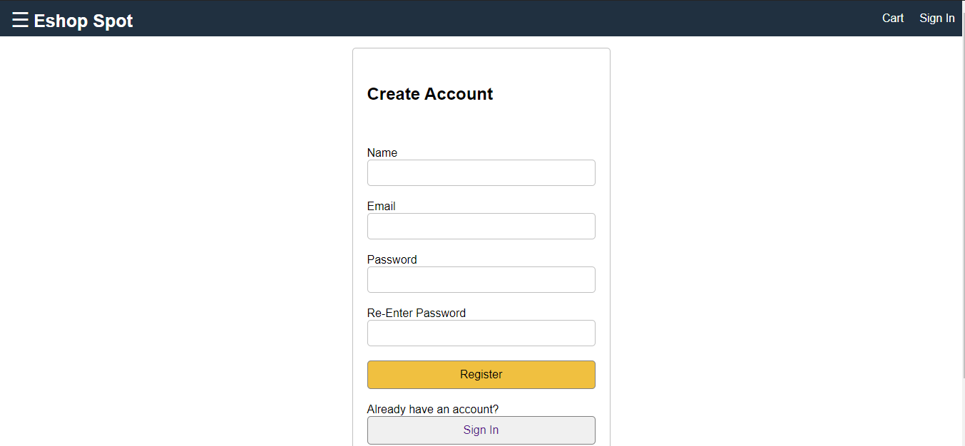

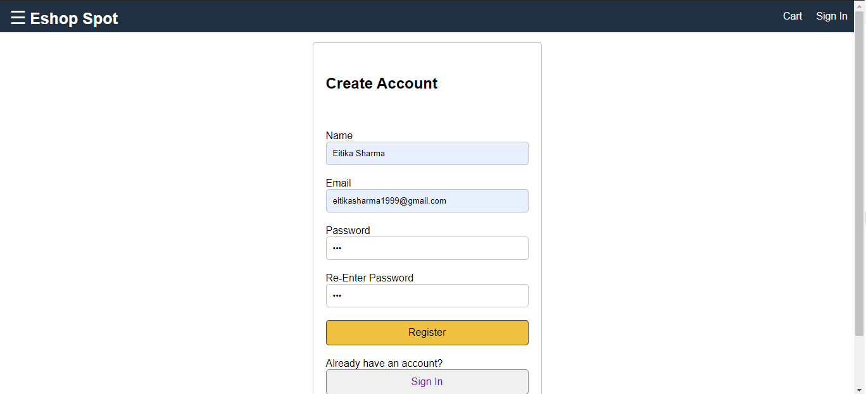 Snapshot 6

Snapshot 7

If we click on the sign in button on the navigation bar, it takes you to the sign-in page (Snapshot 8). If you are a user and not a visitor then you can log in by entering the email id and the password, but if you are a visitor then you need to register first, for that on the sign-in page below the sign-in button there is a button which says if you are new to Eshop Spot then create your Eshop Spot account first. By clicking on that button it takes us to the register page (Snapshot 6), in which we have to enter the name, email id and password and press the register button.

## SIGN IN PAGE:

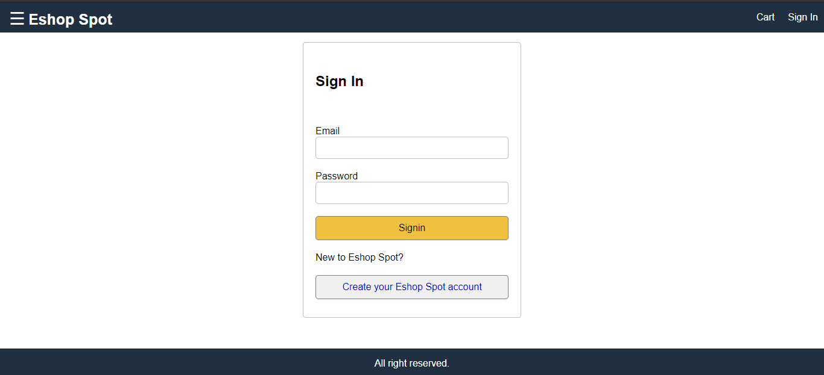

Snapshot 8

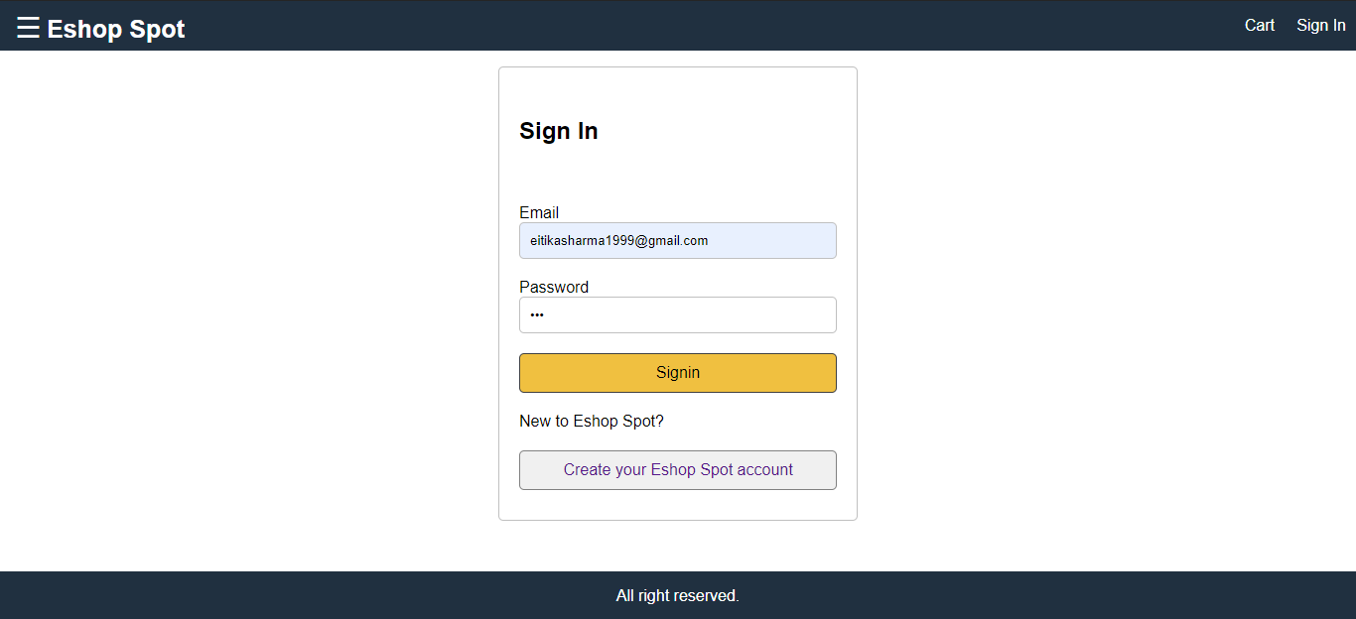

Snapshot 9

Once you become a user and are signed in, you will come on the home page again with a slight change of user’s name on the right side of the navigation bar (Snapshot 10).

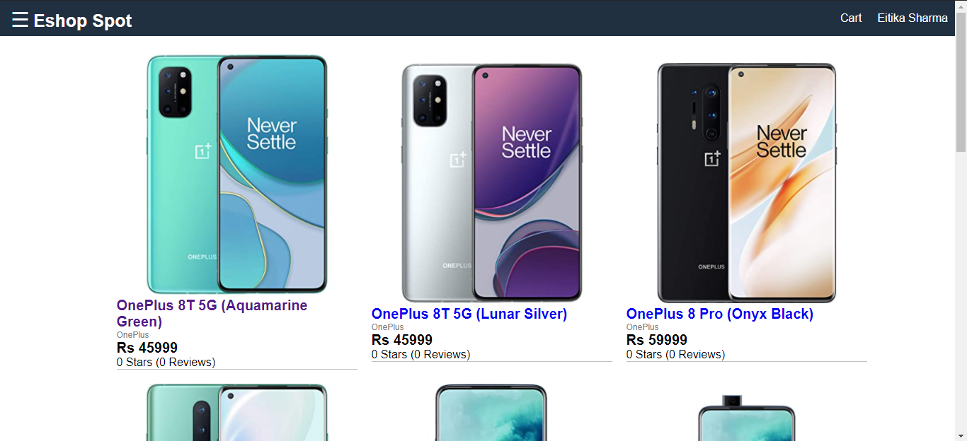

Snapshot 10

## PRODUCT PAGE:

The product page shows the detailed description of the product (Snapshot 11).

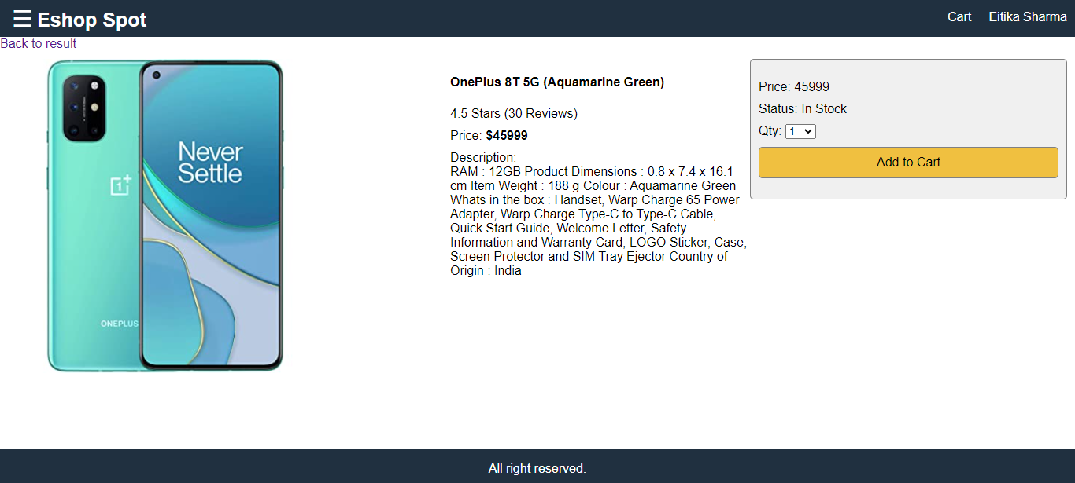

Snapshot 11

On the right of the page, the price and whether the product is in stock or not is shown. User can increase the quantity of a product from 1 to the total number of products in stock, User cannot select more than that. Once everything is done, then user can click on add to cart button to move to the shopping cart page (Snapshot 11).

## CART PAGE:

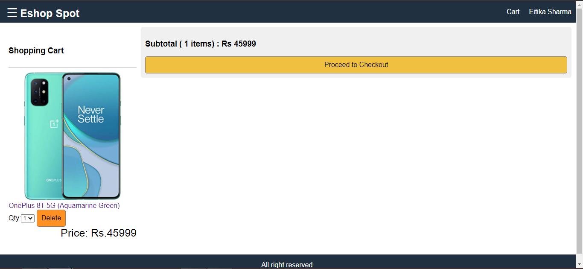The cart page shows the selected the products that a user wants to buy. This page shows the total products selected and the total price of all the products (Snapshot 12). A user can delete the product from this cart page and also can change the quantity of the products.

Snapshot 12

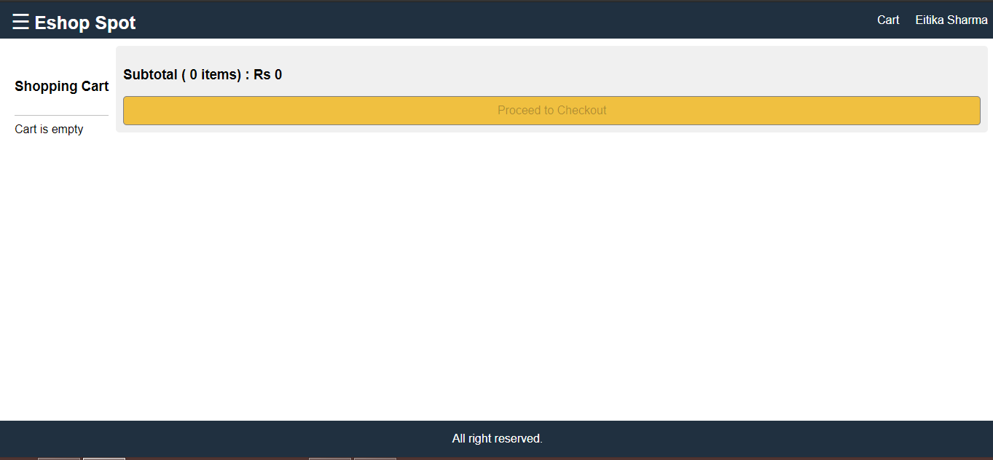If we delete all the products from the cart it shows shopping cart is empty (Snapshot 13).

Snapshot 13

## SHIPPING PAGE:

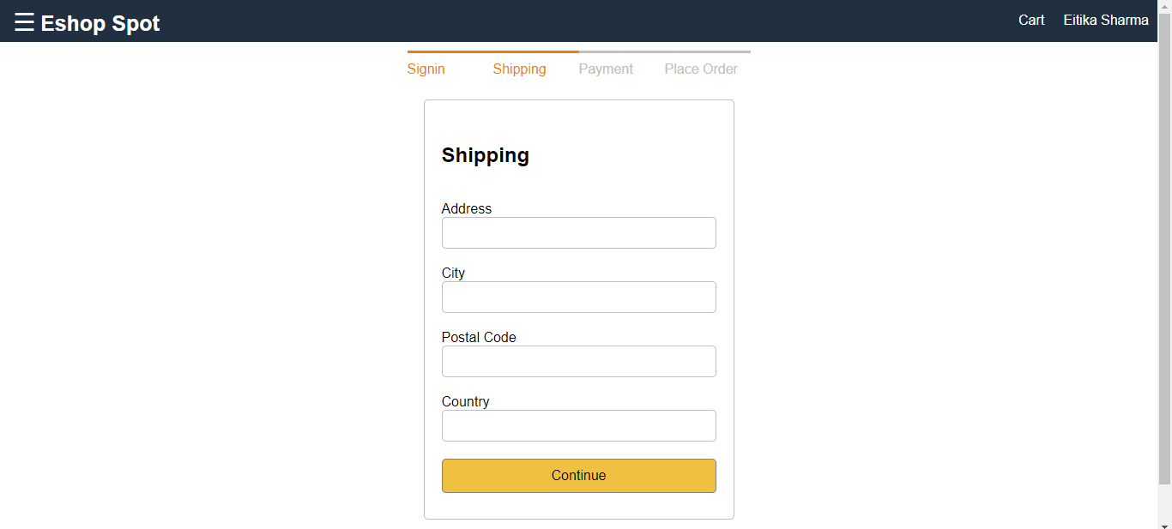After selecting all the products, user will click on proceed to checkout, after that the shipping screen will be displayed (Snapshot 14).

Snapshot 14

The purpose of shipping page is to give the address of the user, where the products are to be delivered. The shipping page takes 4 inputs, Address, City, Postal Code and Country (Snapshot 15). This shipping address is saved in the database, for the easy management and delivery of products.

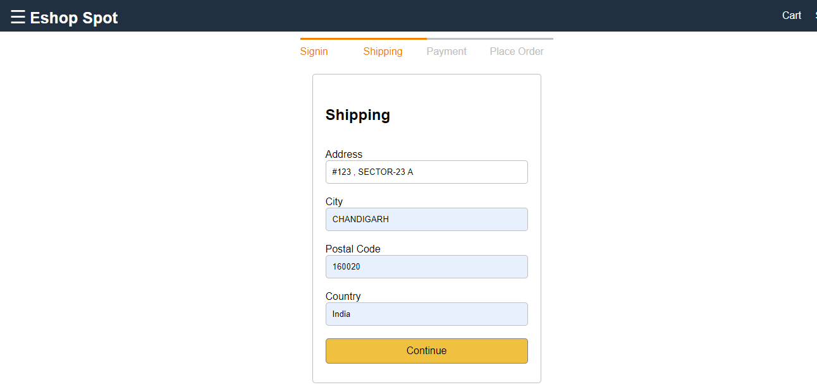

Snapshot 15

After giving all the 4 inputs, user will click on continue button, and then the payment screen will be displayed.

## PAYMENT PAGE:

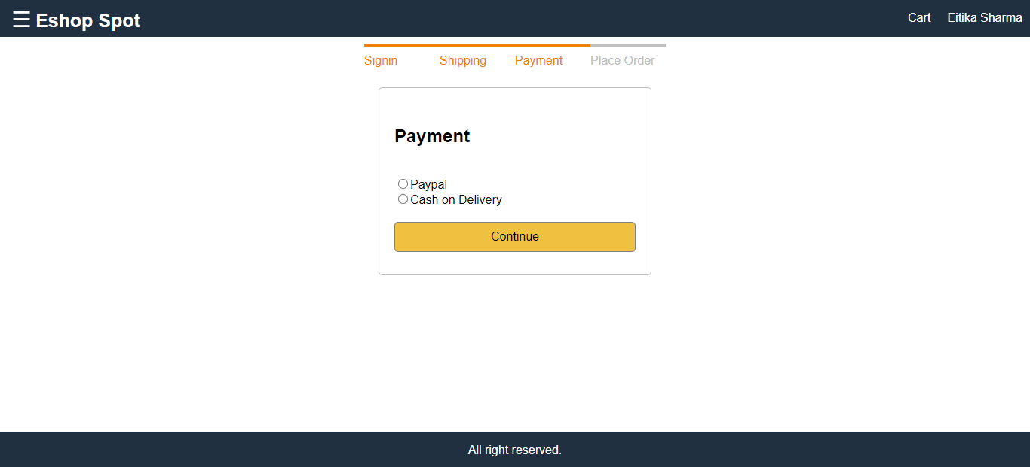

Snapshot 16

The Payment page is used to select the mode of payment through which the payment of the selected products is to be done. The Page shows two Radio buttons that are used to select two modes of payments, one is for PayPal and other is for Cash on Delivery. The user has to select one of these options compulsorily (Snapshot 16). After selecting the option, the user will select the continue button. If we select the cash on delivery option then we are taken to the place order Page and if we select the PayPal option then also we are taken to the Place Order Page (Snapshot 17 and Snapshot 18).

## ORDER PAGE:

This page shows the shipping address, mode of Payment and the shopping cart (selected products) on the left of the page and place order button and order summary with the total price of all the selected products added with the tax.

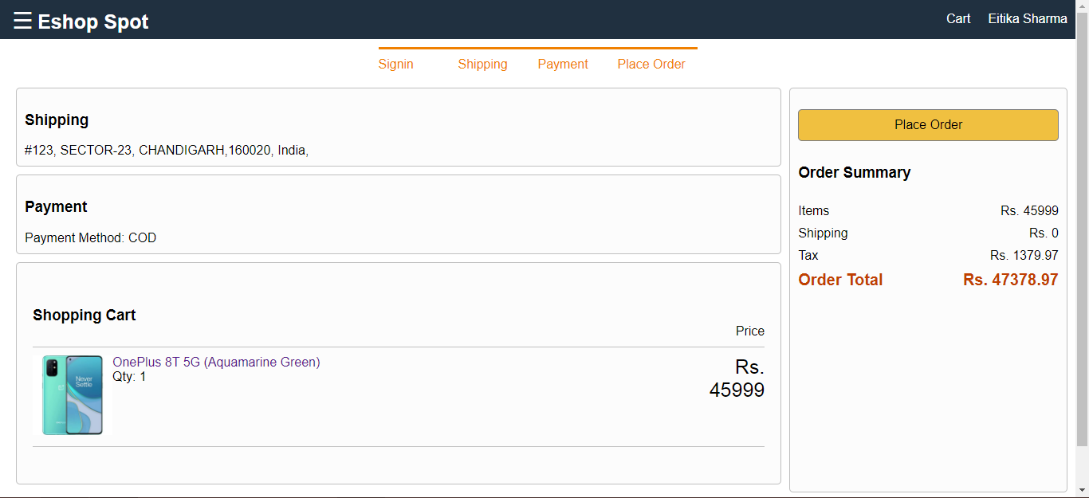

Snapshot 17

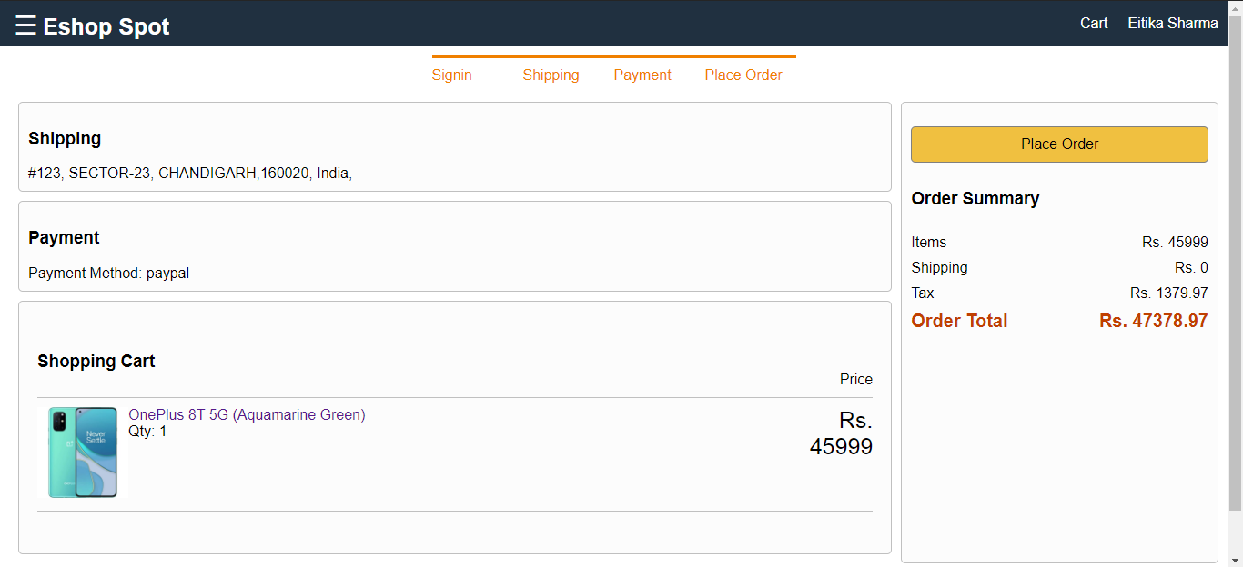

Snapshot 18

As we can see the difference between the Snapshot 17 and Snapshot 18, this difference is because we have selected different mode of payment. If we have selected mode of payment as Cash on Delivery then it shows place order button, on clicking on that button we are taken to the profile page. If we select mode of Payment as PayPal then it will show PayPal button, on clicking on the PayPal button we will be redirected to the PayPal portal.

## ADMIN’S VIEW

The Admin is the controller of the website. He/she can login using his own id and password. Our website can have only one admin at a time because of the security issues.

Admin’s view is almost the same as that of user’s view. The navigation bar has 2 buttons on the right that are cart, name of the admin (Snapshot 19). Cart and name of the admin works the same as that in user’s view.

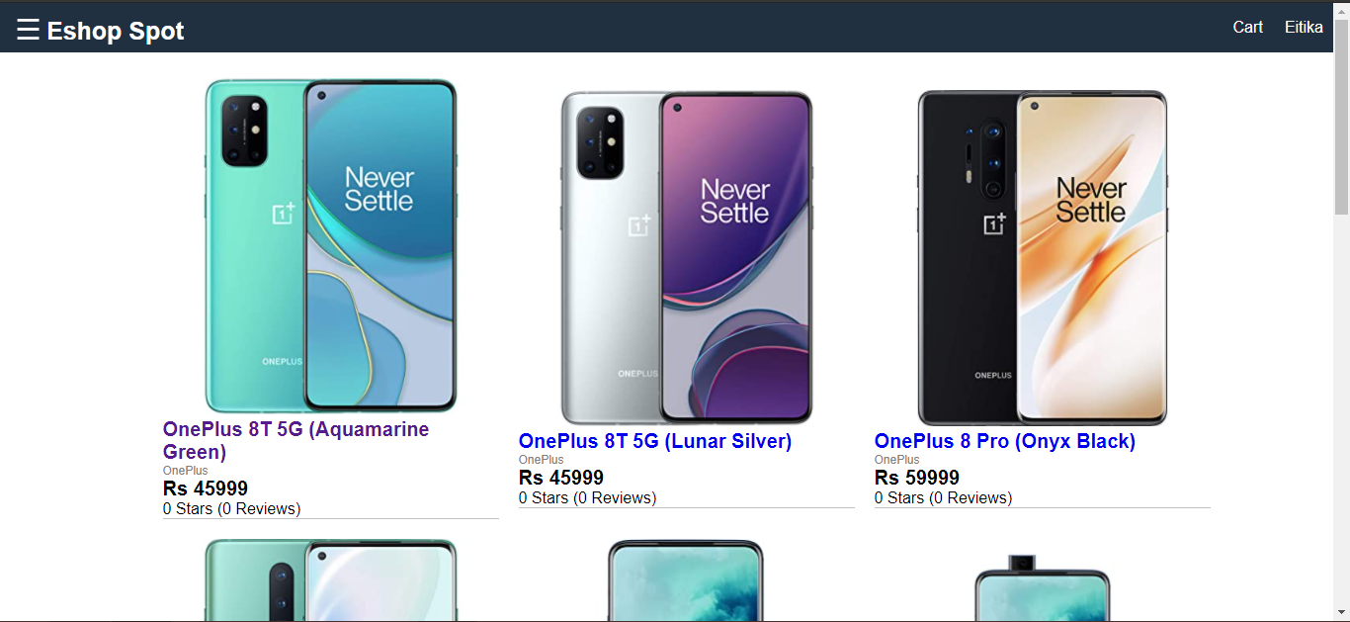

Snapshot 19

Admin has the rights to edit/delete the orders and add new products and edit / delete the already uploaded products (Snapshot 20).

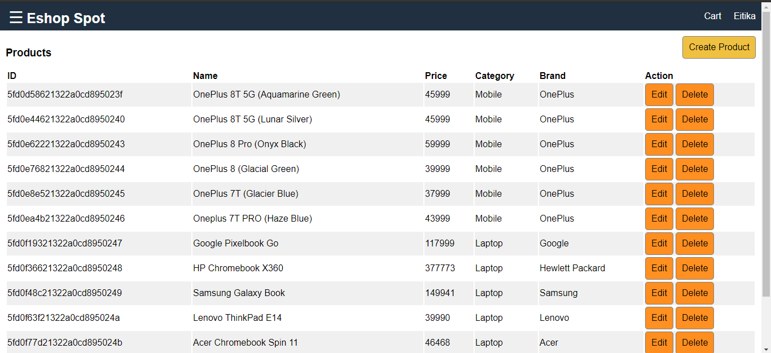

Snapshot 20

Admin can edit the product details and also can delete the product. Admin can also create a new product by entering the following details as shown in Snapshot 21.

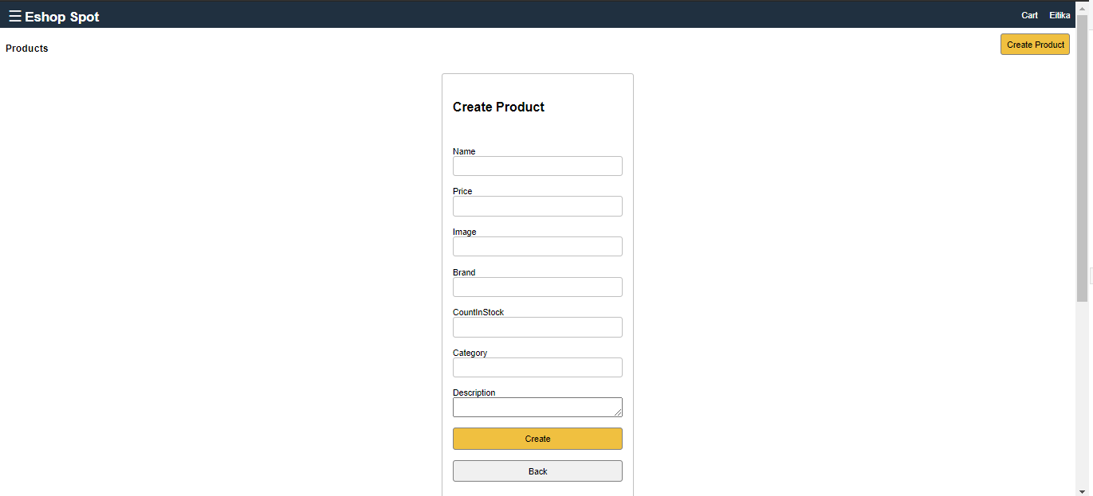

Snapshot 21

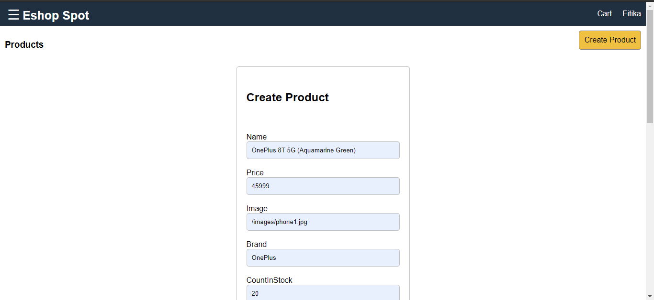

Snapshot 22

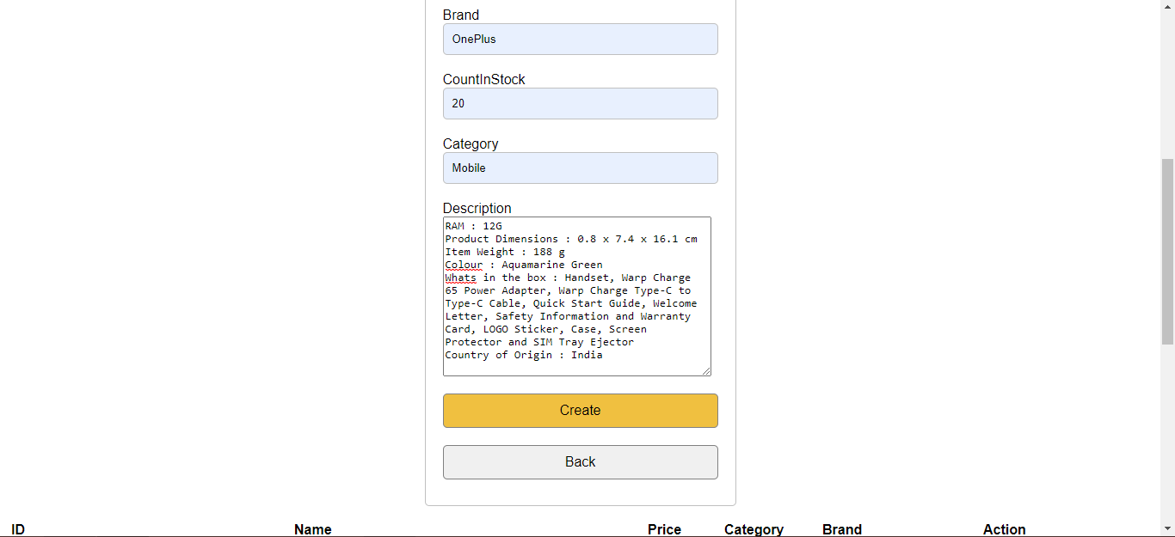

Snapshot 23

FUTURE SCOPE

* GUI modification
* Integration of online payment gateways
* Signup/ Login using social media accounts such as Facebook, Gmail
* Addition of more products
* Final deployment of website